--Triple Beam Balance--
Lab Safety:
- You will be using glassware.
- Do NOT move balances.
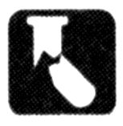

Purpose: Determine the mass of an object using 3 methods.
- Direct measurement.
- Mass by Difference.
- Mass exact amounts.

Materials:
- Triple Beam Balance Various objects to mass.

Part 1: Parts of the Balance
Label the diagram, and find the parts on your balance.

Pointer Marker The part of the beam that moves up and down, indicating a balance.
Zero point center The line on the scale that tells you when the beam is balanced.
Adjustment knob On the left, the knob that will adjust a balance.
Pan The metal platform that you put objects on.
Beams The ruler-like scales, measuring grams.
Riders The moveable markers that point to a number of grams.

pan
beams
pointer marker

adjustment knob
riders
zero point center

Getting Ready:
- Clean off Pan
- Set Riders to Zero
- Make sure the pointer marker is at zero
- Adjust if necessary

Data: Measuring Mass Directly.
Object:
250 ml Beaker
Washer
Stopper
Index Card
10 mL cylinder
100 g Rider
10 g Rider
1 g Rider
TOTAL
Part 2: How to use the Balance to Measure Mass Directly

Place the object that you want to mass on the pan.
Move the riders until the pointer-marker reads zero.
Move the 100g marker to the right, until the beam drops, then move it back one notch.
Move the 10g marker to the right until the beam drops, then move it back one notch.
Move the 1g marker to the right until the beam is balanced.
The object’s mass is the TOTAL of the readings on all 3 riders.
Remove object and set all the riders to zero.
Plastic Cup
100 mL cylinder
Calculator
Your shoe
Your Pencil

Part 3: Mass by Difference.
Mass of plastic cup:
Mass of cup and 1 marble:
Difference
Mass of 100 mL cylinder:
Mass of cylinder and 75 mL water:
Difference

Mass of plastic cup:

Mass of cup and 10 marbles:

Difference

Part 3: Mass by Difference
Mass the container when it is empty.
Put the substance in the container.
Find the mass of the full container
Subtract to find the mass of the substance in the container.
Return substances to where you got them from.
All your containers have been massed already!
Volumes are approximate only! Do not worry about exact volumes, just exact masses!
Mass of index card:
Mass of card and 1 scoop sand:

Difference

Mass of beaker:
Mass of beaker and 100 mL water:
Difference

Mass of 10 mL cylinder:
Mass of cylinder and 10 L of water
Difference

Mass of cup:

Mass of cup full of sand:

Difference

Mass of beaker:
Mass of beaker and 200 mL water:
Difference

Make sure you empty out your containers when you are done with them!

Part 4: Massing Exact Amounts
When you need to measure out an exact amount of a substance, as in the quantities for a recipe, or chemical formula, there is a different process.
Find the mass of the container.
Add the mass of the container and the mass of the substance that you need.
Set the riders to that amount.
Fill the container until the balance is balanced.
When you have accomplished this, have your partner sign your sheet, and put everything back.

Find exactly 12 g of sand.
Find exactly 50 g of water

Mass of plastic cup:
12g of sand
Set riders to:

+12g

Set riders to:

+50g

Mass of 100 mL cylinder:
50g of sand

My partner made a 50 g sample of water:
My partner made a 12 g sample of sand:

Part 5: Questions

- When is the balance BALANCED? (Use vocab words!)

- What is the smallest mass you can find accurately?

- What is the largest mass you can find accurately?

- What do you always need to check before using the balance?

- What do you do after finding the mass of an object?

- What types of situations would you need to find mass using “mass by difference?”

- What types of situations would you need to find mass using “massing exact amounts?”

--Triple Beam Balance--
Name

Date
Period
Lab Safety:
- You will be using ________________.
- Do NOT _______________________.

Purpose: Determine the mass of an object using 3 methods.
- _________________________.
- _________________________.
- _________________________.

Materials:
- _____________________ _____________________

Part 1: Parts of the Balance
Label the diagram, and find the parts on your balance.

Pointer Marker The part of the beam that moves up and down, indicating a balance.
Zero point center The line on the scale that tells you when the beam is balanced.
Adjustment knob On the left, the knob that will adjust a balance.
Pan The metal platform that you put objects on.
Beams The ruler-like scales, measuring grams.
Riders The moveable markers that point to a number of grams.

Getting Ready:
- Clean off Pan
- Set Riders to Zero
- Make sure the pointer marker is at zero
- Adjust if necessary

Data: Measuring Mass Directly.
Object:
250 ml Beaker
Washer
Stopper
Index Card
10 mL cylinder
100 g Rider
10 g Rider
1 g Rider
TOTAL
Part 2: How to use the Balance to Measure Mass Directly

Place the object that you want to mass _____________.
Move the riders until the pointer-marker reads zero.
Move the _______ marker to the right, until the beam drops, then move it ___________________.
Move the _______ marker to the right until the beam drops, then move it _______________.
Move the __ marker to the right until the beam is ________.
The object’s mass is the _______ of the readings on all 3 riders.
Remove object and set all the riders to zero.
Plastic Cup
100 mL cylinder
Calculator
Your shoe
Your Pencil

Part 3: Mass by Difference.
Mass of plastic cup:
Mass of cup and 1 marble:
Difference
Mass of 100 mL cylinder:
Mass of cylinder and 75 mL water:
Difference

Mass of plastic cup:

Mass of cup and 10 marbles:

Difference

Part 3: Mass by Difference
Mass the _________ when it is empty.
Put ______________ in the container.
Find the mass of the full container
_________ to find the mass of the substance in the container.
Return substances to where you got them from.
All your containers have been massed already!
Volumes are approximate only! Do not worry about exact volumes, just exact masses!
Mass of index card:
Mass of card and 1 scoop sand:

Difference

Mass of beaker:
Mass of beaker and 100 mL water:
Difference

Mass of 10 mL cylinder:
Mass of cylinder and 10 L of water
Difference

Mass of cup:

Mass of cup full of sand:

Difference

Mass of beaker:
Mass of beaker and 200 mL water:
Difference

Make sure you empty out your containers when you are done with them!
Name

My partner made a 50 g sample of water:
My partner made a 12 g sample of sand:
Part 5: Questions

- When is the balance BALANCED? (Use vocab words!)

- What is the smallest mass you can find accurately?

- What is the largest mass you can find accurately?

- What do you always need to check before using the balance?

- What do you do after finding the mass of an object?

- What types of situations would you need to find mass using “mass by difference?”

- What types of situations would you need to find mass using “massing exact amounts?”

Part 4: Massing Exact Amounts
When you need to measure out an exact amount of a substance, as in the quantities for a recipe, or chemical formula, there is a different process.
Find the mass of the ________________.
Add the mass of the container and the mass of the substance that you need.
Set the riders __________________.
Fill the container until the __________________________.
When you have accomplished this, have your partner sign your sheet, and put everything back.

Find exactly 12 g of sand.
Find exactly 50 g of water
Mass of plastic cup:
12g of sand
Set riders to:

+12g

Set riders to:

+50g

Mass of 100 mL cylinder:
50g of sand

Each group needs

Washer
Stopper
Plastic cup
index card
10 mL Cylinder
100 mL Cylinder
250 mL Beaker

Pairs need
Sand
Water
10 marbles

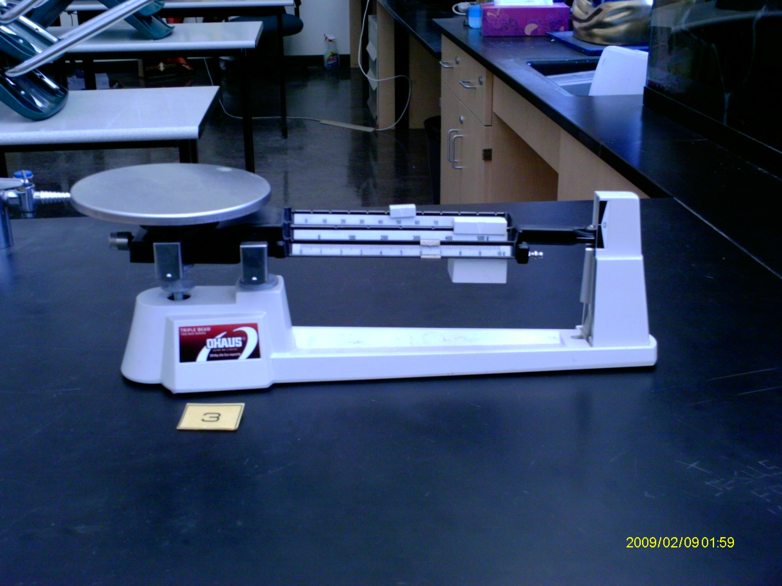

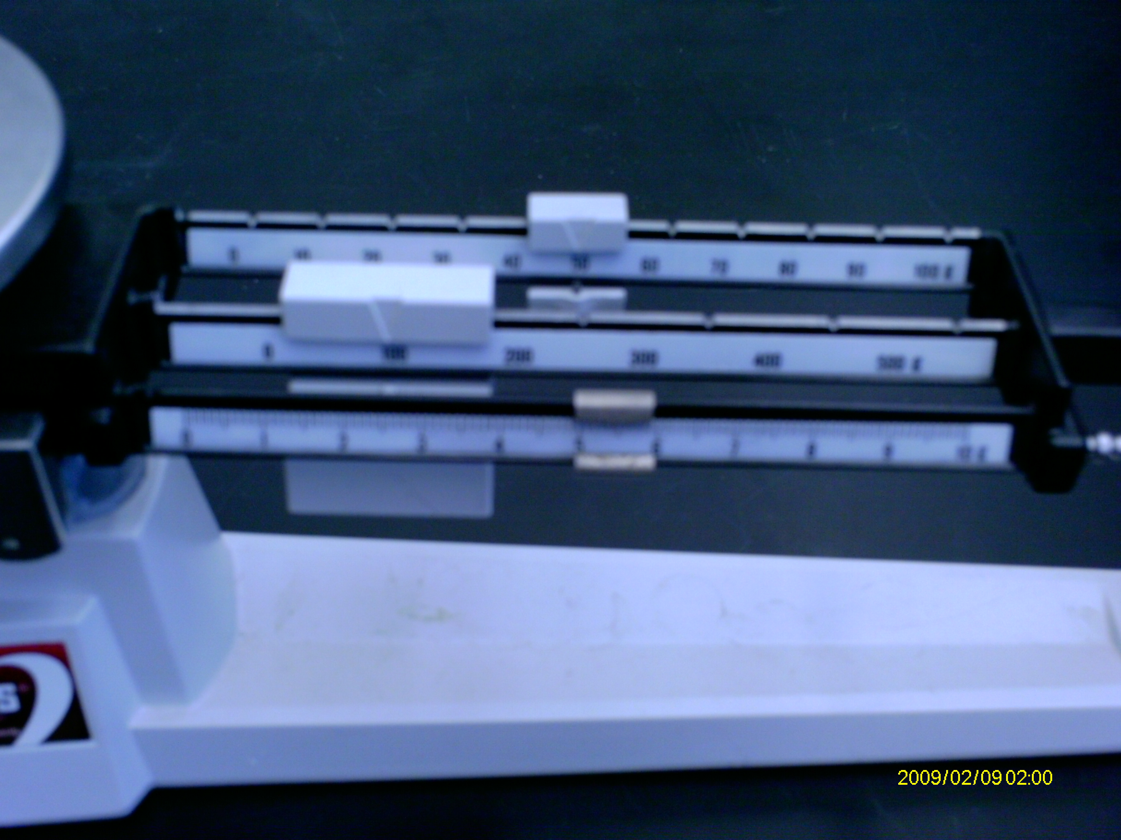

--Balanza de Tres Vigas
Proposito:Determina la masa de un objecto usando 3 metodos.
Medida directa.
Peso de diferencia
Pesando cantidades exactas.
Procedimiento:
Completa las 6 partes del laboratorio:
Partes de la balanza
Com usar la balanza
Masa de medir directamente
Peso por diferencia
Pesando cantidades exactas
Conclucion

Segudidad:
Vas a usar cristaleria..
Materiales:
Balanza de tres vigas
Un cilindro graduado de 100 mL
Un frasco de 250 mL
Toalla de papel
Varios objectos en masa.

Parte 1: Partes de la Balanza
Con tu comaanero, encuentra las partes siguientes de las balanza.

Marcador IndicadorLa parte le las vigas que se mueven hacia arriba y abajo, indicando un balanza.
Cero punto centralLa linea sobre la bascula que te dice cuando la viga este balanciada.
Boton de ajusteSobre la izquierda, el boton que ajustara un balance.
PlatilloLa plataforma de metal donde pones los objectos.
VigasLa regal-como bascula, midiendo gramos.
Pesa corredizaLos marcadores moviles que indican el undero de gramos.
Parte 2: Como Usar la Balanza

Pon la balana wn una superficie plana. Siempre mueve la balanza por la base.
Coloca todas las pesas corredizas en cero.
ANTES de poner un objecto en pl platillo, el indicador debe estar en el punto cero.
Si el indicador no esta en cero, ajusta el boton para que la balanza este en cero.
Pon el objecto que quieras pesar sobre el platillo.
Mueve las penas corredizas hasta que el indicador muestre cuerro.
Mueve el marcador de 100g a la derecha, hasta que la viga baje, entonces muevela un grado hacia atras.
Mueve el marcador de 10g a la derecha, hasta que la viga baje, entonces muevela un grado hacia atras.
Mueve el marcador de 1g a la derecha, hasta que la viga este balanceada.
La masa del objecto es el TOTAL de las tres pesas corredizas.
Remueve los objectos y pon todas las pesas corredzas en cero.

Parte 3: Media de Masa Direcamente:

Mide los objectos directamente sobre el platillo y anota los dados en tu grafica.

arandelacilindro graduado de 100 mL
tapon de gomaFrasco de 250 mL.
encuadernador Un objecto de tu selecion.

1:
Mass the cup
La masa de una copa
Pon la canica dentro le la copa.
Encuentra la masa de la copa y canica.
Encuentra la diferencia de las dos masas.

Part 5: Masa de Cantidades Exactas

Prepara un ejemplo de agua de 100g exactamente.
Masa la frasco.
Mueve la pesa corrediza de 100g un paso a la derecha.
Cuidadosamente agrega agua al frasco hasta que apunte el balance.
Has que tu companero firme tu hoja de dados.

Prepara un ejemplo de exactamente 12g de sal.
Dobla una hoja de papel en cuatro partes, desoblala, y ponly sobra el platillo.
Pesa la masa le la hoja de papel.
Mueve las pesas corredizas para leer 12g mas.
Mueve la pesa corrediza de 10g mas um pasp y mueve la de 1g mas de 2g.
Cuidadosamenta agrege sal hasta que apunte cero.
Has que tu companero firme tu hojs de dados.
2:
Masa del cilindro graduado.
Llenalo con 75mL de agua.
Encuentra la masa del cilindro lleno.
Encuentra la diferencia de las dos masas.
3:
Dobla un pedazo de papel de toalla entra cuartos, desdoblado, y ponlo en el platillo.
Masa de la hoja de papel.
Pon una cucharada de sal sobre el papel.
Encuentra la masa.
Encuentra la diferencia de las dos masas.
Part 4: Mass by Difference
Parte 6 Conclucion:

La balanza de tres viga en balanceada cuando…
Las partes que mueves a la izquierda y derecha, las cuales indica masa se llaman.
Cual es la masa mas pequena que puedes encontar exactamente?
Cual el la masa mas grande que puedes encontar exactamente?
Antes de usar la balanza es necesario que siempre inspecciones…
Despues de encontrar la masa de un objecto, remueve el objecto, entonces es necesario…
Que tipos de situaciones necesitas para encontrar masa usando “masa por diferencia?”
Que tipos de situaciones necesitas para encontrar masa usando “Cantidad de masa exacta”

